**DATA COMMUNICATION**

**LAB 4: BLUETOOTH MODULE**

# Introduction to Bluetooth HC06

HC-06 is a Bluetooth device used for wireless communication with Bluetooth enabled devices (like smartphone). It communicates with microcontrollers using serial communication (UART). This device adds wireless communication protocol to the embedded applications through which it can communicate with any other Bluetooth enabled device.

**Note**: Default Bluetooth name of the device is “HC-05” and default PIN (password) for connection is either **“0000”** or **“1234”.**

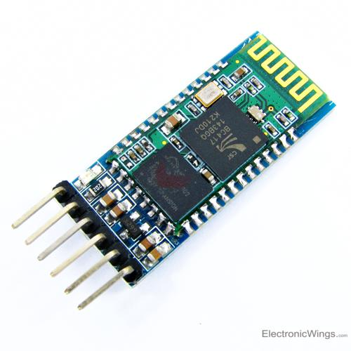

Figure 1: HC06 Bluetooth Module

# Example

In this manual, a small application in which we can control LED ON-OFF through a smartphone. This is done by interfacing HC-06 Bluetooth module with NodeMCU. Data from HC-06 is received/ transmitted serially by NodeMCU.

In this application, when a character ‘1’ is sent from smartphone, LED will turn ON and if ‘2’ is sent LED will get turned OFF. If received data is other than ‘1’ or ‘2’, it will return message to mobile that select proper option. The proposed connection can be found in Figure 2. For easily setup, please use the available LED on pin 13 instead of 4 as showed in the Figure 2.

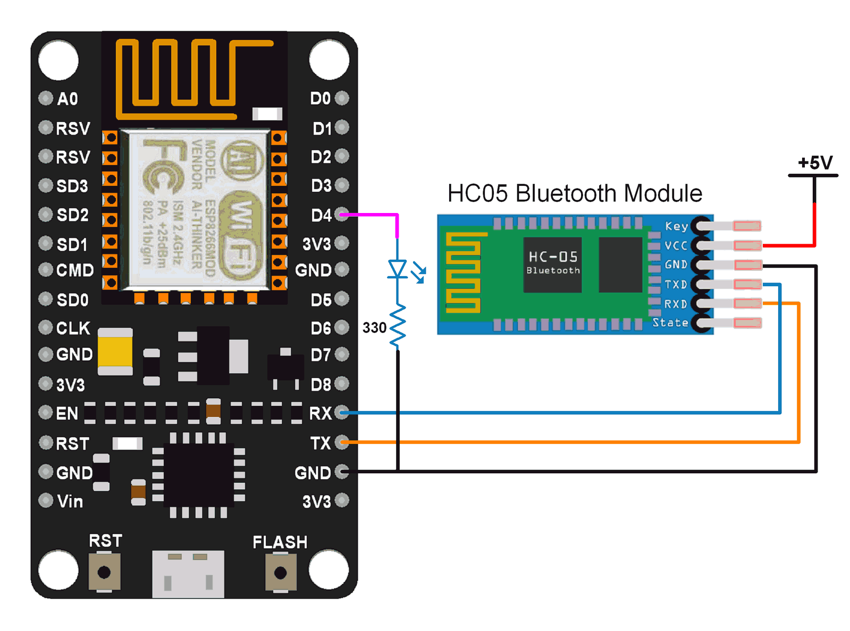

Figure 2: Connection between NodeMCU and HC-06

Following source code can be implemented on NodeMCU in order to control the LED

int LED = 13;

void setup() {

pinMode(LED, OUTPUT);

Serial.begin(9600); /* Baud rate for serial communication */

}

void loop() {

if (Serial.available()) {

char data_received;

data_received = Serial.read();

if (data_received == '1')

{

digitalWrite(LED, HIGH);

Serial.write("LED turned ON\n");

}

else if (data_received == '2')

{

digitalWrite(LED, LOW);

Serial.write("LED turned OFF\n");

}

else

{

Serial.write("Select either 1 or 2");

}

}

}

# HC-06 Connecting to an Android Device

Since the HC-06 is a slave only device, the connection must be started by another device. Below are the steps to pair and then connect with an Android device.

1. Before you can connect to the HC-06 you need to pair it. Power on the HC-06. The LED will flash rapidly.
2. Open Settings on the Android device and select Bluetooth.
3. If your device does not auto-scan you will need to manually scan for available Bluetooth devices. The HC-06 should appear in the list.
4. Select the HC-06. You will be asked for the pin. The default pin is “1234”.
5. The modules name may include the mac address; a series of hexadecimal numbers.

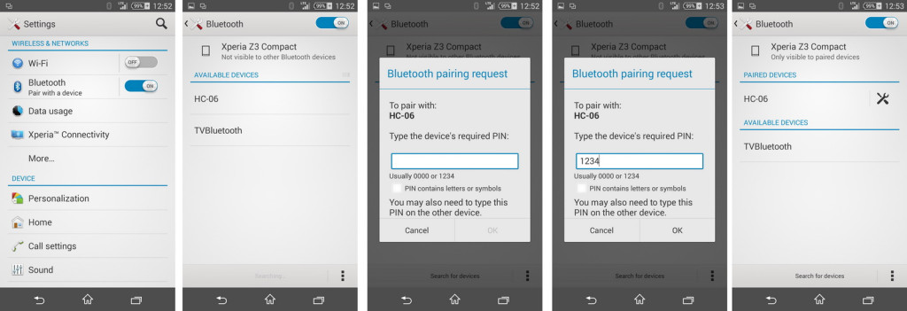

Figure 3: Connect HC-06 to an Android device in Setting

After the HC-06 is paired you need to communicate with it somehow. To test things are working you can use a BT terminal program such as Bluetooth Terminal available on Google Play.

1. Install and open Bluetooth Terminal.
2. Open the menu, icon at the top of the screen.
3. Select “Connect a device – Insecure”. This brings up a list of available devices.
4. Select the HC-06
5. Once connected, “connected: HC-06″ is displayed at the top of the screen.

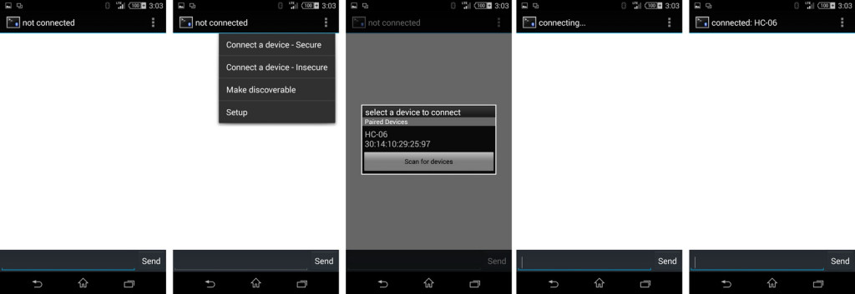

Figure 4: Connect a Bluetooth Terminal and HC-06

After this step, your Android phone and the MCUNode can send and receive some messages and the LED is controlled accordingly if ‘1’ or ‘2’ are received.

# Exercise

1. Currently, in the manual the real Serial is used to control the HC-06 module. Implement a new program but the Software Serial Library is used to connect to the HC-06. Assume that D2 and D3 are Rx and Tx pins
2. Instead of receiving ‘1’ and ‘2’ to turn on or turn off the LED, the commands are change to “ON” and ”OFF”. Design your system by a DFA and then, implement it.

# Extra exercise

Create an Android App like the Bluetooth terminal you are using in this lab. Currently, MIT is a very powerful tool to create some demo like this. Please check this link for your reference <https://www.youtube.com/watch?v=mUOLsNQ8Q1k>